Mini Project Report
Air Quality Index (AQI) Monitoring

Submitted By
Name : B.Manobhiram
Reg No: 11249A046
CSE Department | Section S5
R-Programming Lab
SCSVMV UNIVERSITY

Experiment 3: Air Quality Index (AQI) Monitoring

Aim
To collect, analyse, and visualize Air Quality Index (AQI) data from multiple cities using R programming, and to interpret pollution levels using bar charts, histograms, box plots, and pie charts.

Scenario / Background
- Environmental monitoring agencies collect daily AQI readings from sensors placed across major Indian cities.
- The AQI value reflects the concentration of key pollutants: PM2.5, PM10, CO, NO2, SO2, and O3.
- Government bodies and the public use AQI categories (Good, Moderate, Unhealthy, Very Unhealthy, Hazardous) to decide health advisories.
- Analysing AQI trends helps identify cities with chronic pollution problems and the most common primary pollutants.
- Visualizing the data allows policymakers to take targeted action to improve air quality and public health outcomes.

Sample Dataset
The dataset contains 10 records from 5 Indian cities collected over 10 consecutive days.
Station ID | Date | City | AQI Value | Pollutant Conc. (µg/m³) | Primary Pollutant | AQI Category
S001 | 2024-01-15 | Chennai | 142 | 45 | PM2.5 | Unhealthy
S002 | 2024-01-16 | Mumbai | 89 | 30 | PM10 | Moderate
S003 | 2024-01-17 | Delhi | 210 | 60 | PM2.5 | Very Unhealthy
S004 | 2024-01-18 | Kolkata | 55 | 20 | CO | Good
S005 | 2024-01-19 | Bangalore | 78 | 25 | NO2 | Moderate
S006 | 2024-01-20 | Chennai | 165 | 50 | PM2.5 | Unhealthy
S007 | 2024-01-21 | Mumbai | 38 | 10 | SO2 | Good
S008 | 2024-01-22 | Delhi | 295 | 80 | PM2.5 | Hazardous
S009 | 2024-01-23 | Kolkata | 110 | 35 | PM10 | Unhealthy for Sensitive
S010 | 2024-01-24 | Bangalore | 62 | 22 | O3 | Moderate

R Program (with line-by-line comments)

# ============================================
# Experiment 3: Air Quality Index Monitoring
# ============================================

# Step 1: Load required libraries
library(ggplot2) # For creating visualizations
library(dplyr) # For data manipulation

# Step 2: Define the AQI dataset inline
aqi_data <- data.frame(
StationID = c("S001","S002","S003","S004","S005",
"S006","S007","S008","S009","S010"),
Date = as.Date(c("2024-01-15","2024-01-16","2024-01-17",
"2024-01-18","2024-01-19","2024-01-20",
"2024-01-21","2024-01-22","2024-01-23",
"2024-01-24")),
City = c("Chennai","Mumbai","Delhi","Kolkata","Bangalore",
"Chennai","Mumbai","Delhi","Kolkata","Bangalore"),
AQI = c(142, 89, 210, 55, 78, 165, 38, 295, 110, 62),
Pollutant_Conc = c(45, 30, 60, 20, 25, 50, 10, 80, 35, 22),
Primary_Pollutant = c("PM2.5","PM10","PM2.5","CO","NO2",
"PM2.5","SO2","PM2.5","PM10","O3"),
Category = c("Unhealthy","Moderate","Very Unhealthy","Good",
"Moderate","Unhealthy","Good","Hazardous",
"Unhealthy for Sensitive","Moderate")
)

# Step 3: View the dataset
View(aqi_data)
cat("AQI Dataset Loaded Successfully\n")
print(summary(aqi_data))

# Step 4: Bar Chart – Average AQI by City
avg_aqi <- aqi_data %>%
group_by(City) %>%
summarise(Avg_AQI = mean(AQI)) # Compute mean AQI per city

ggplot(avg_aqi, aes(x = City, y = Avg_AQI, fill = City)) +
geom_bar(stat = "identity") + # Draw bars with actual values
labs(title = "Average AQI by City",
x = "City", y = "Average AQI") +
theme_minimal() +
theme(legend.position = "none") # Remove legend (redundant with x-axis)

# Step 5: Histogram – AQI Value Distribution
ggplot(aqi_data, aes(x = AQI)) +
geom_histogram(binwidth = 40, fill = "steelblue", color = "black") +
labs(title = "Distribution of AQI Values",
x = "AQI", y = "Frequency") +
theme_minimal()

# Step 6: Box Plot – AQI spread per City
ggplot(aqi_data, aes(x = City, y = AQI, fill = City)) +
geom_boxplot() + # Show median, IQR, and outliers
labs(title = "AQI Box Plot by City",
x = "City", y = "AQI") +
theme_minimal() +
theme(legend.position = "none")

# Step 7: Pie Chart – Proportion of AQI Categories
category_counts <- table(aqi_data$Category) # Count each category
pie(category_counts,
main = "AQI Category Distribution",
col = rainbow(length(category_counts))) # Assign distinct colors

Output / Observation
- Bar Chart: Delhi records the highest average AQI (~252), followed by Chennai (~153), indicating severe pollution levels. Bangalore and Kolkata show relatively lower average AQI values.
- Histogram: The AQI distribution is right-skewed, with most readings clustered between 38 and 165. One extreme outlier (AQI = 295 for Delhi) highlights hazardous episodes.
- Box Plot: Delhi shows the widest interquartile range and highest median AQI, confirming persistent air quality issues. Mumbai and Bangalore have compact, lower-range distributions.
- Pie Chart: PM2.5 is the dominant primary pollutant (~40% of records), followed by PM10 and other pollutants, reflecting the major role of particulate matter in urban air pollution.
- Overall Insight: The analysis reveals that metro cities like Delhi face chronic high-AQI conditions, primarily driven by PM2.5. Smaller cities like Bangalore maintain relatively better air quality. Monitoring such trends is critical for data-driven environmental policymaking.

Graphs Representation
The following graphs are generated by executing the above R program:
- Graph 1: Bar Chart – Average AQI by City
- Graph 2: Histogram – Distribution of AQI Values
- Graph 3: Box Plot – AQI Spread per City
- Graph 4: Pie Chart – AQI Category Distribution
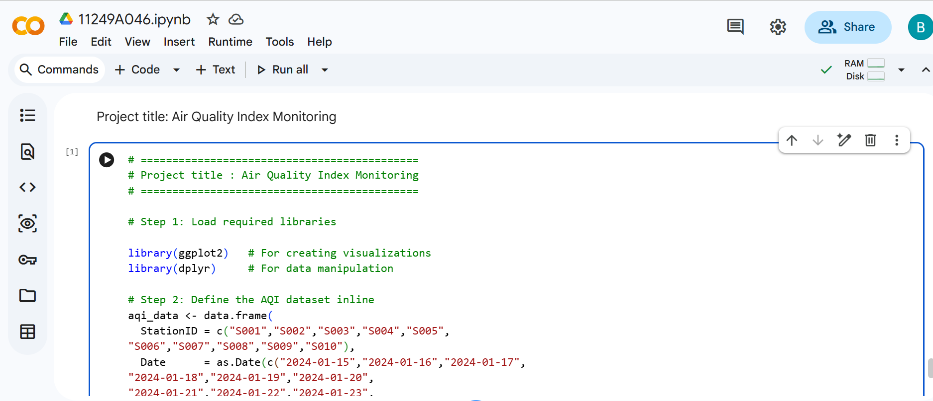
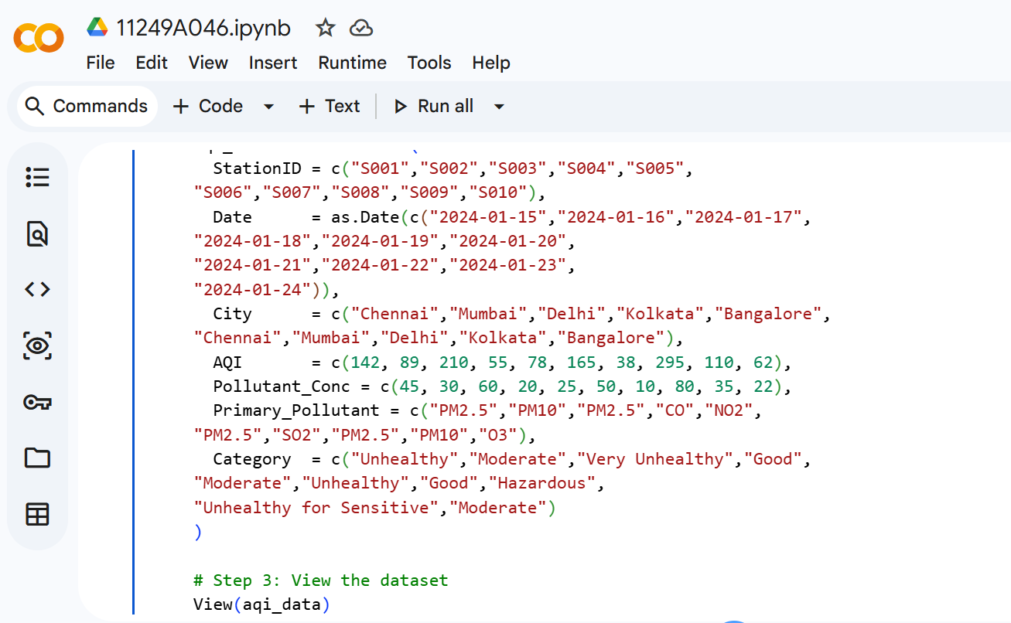

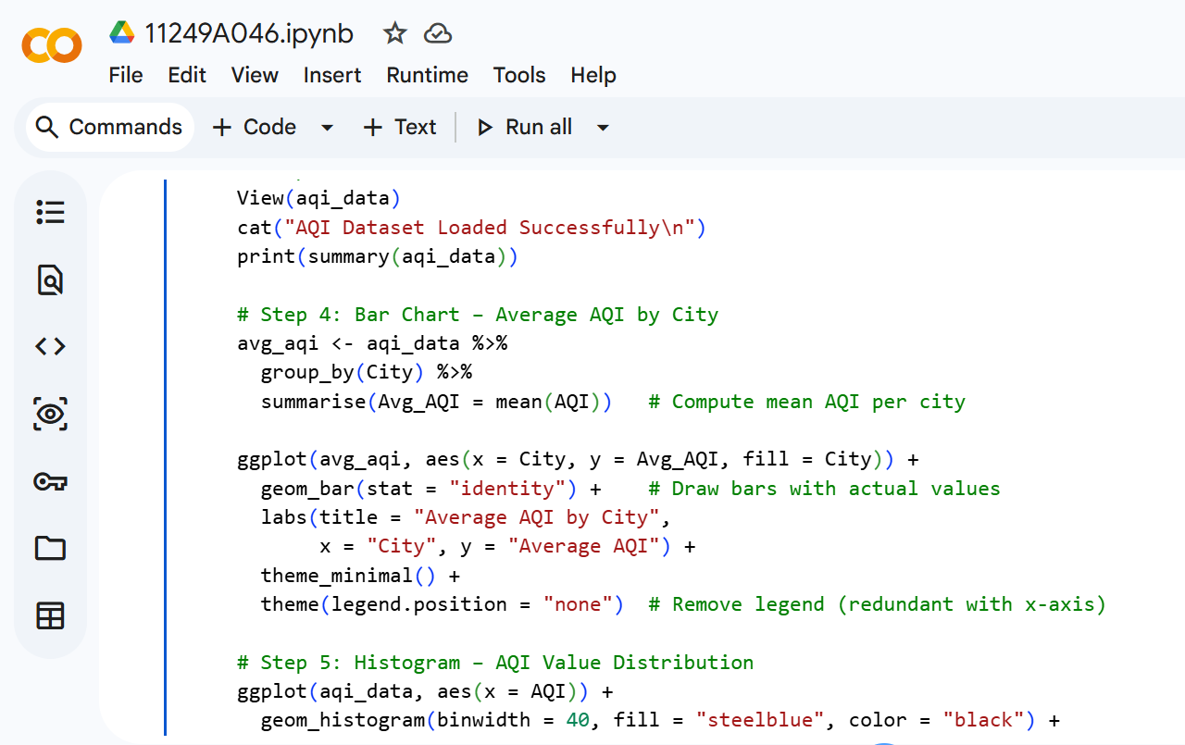

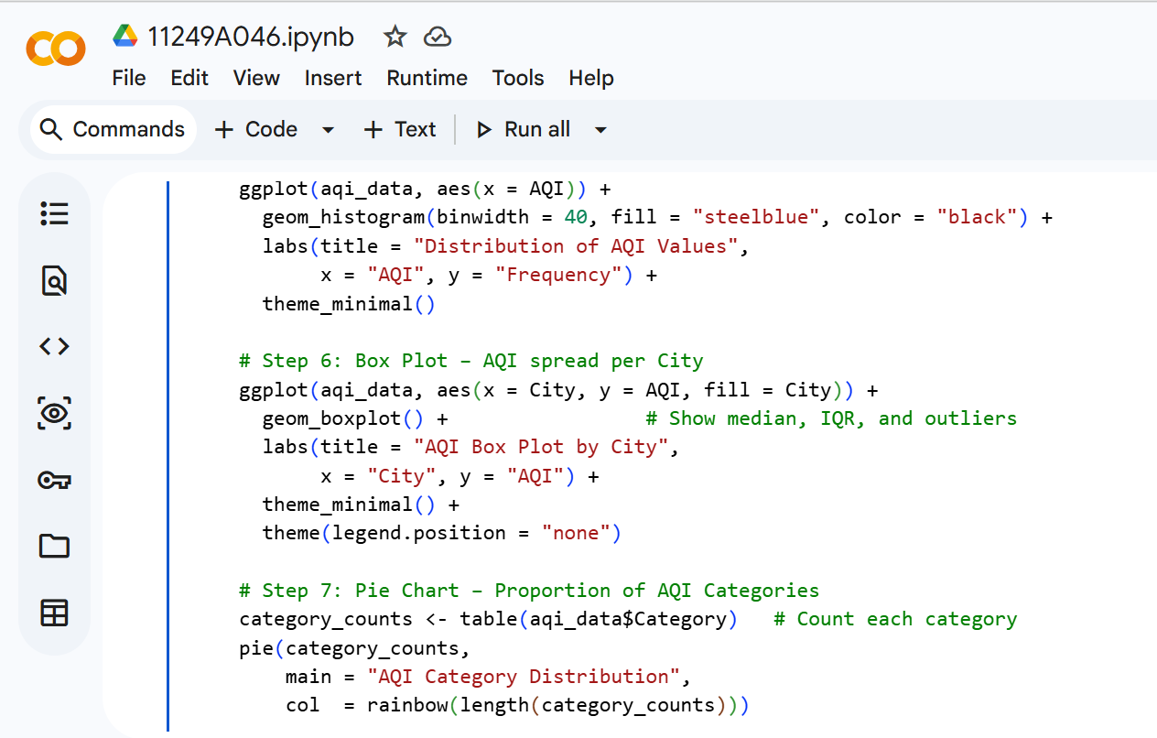
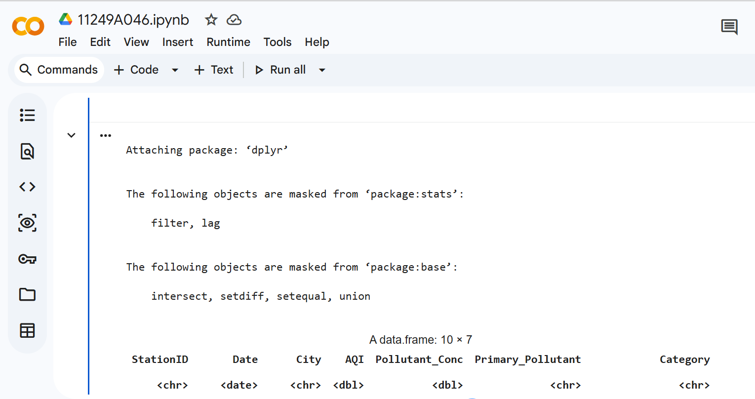

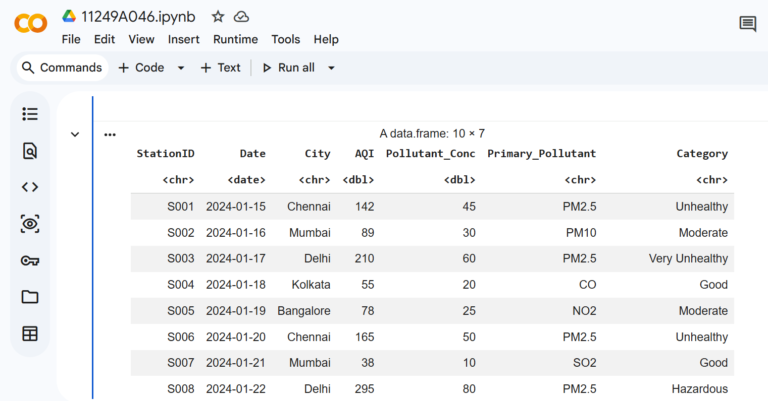

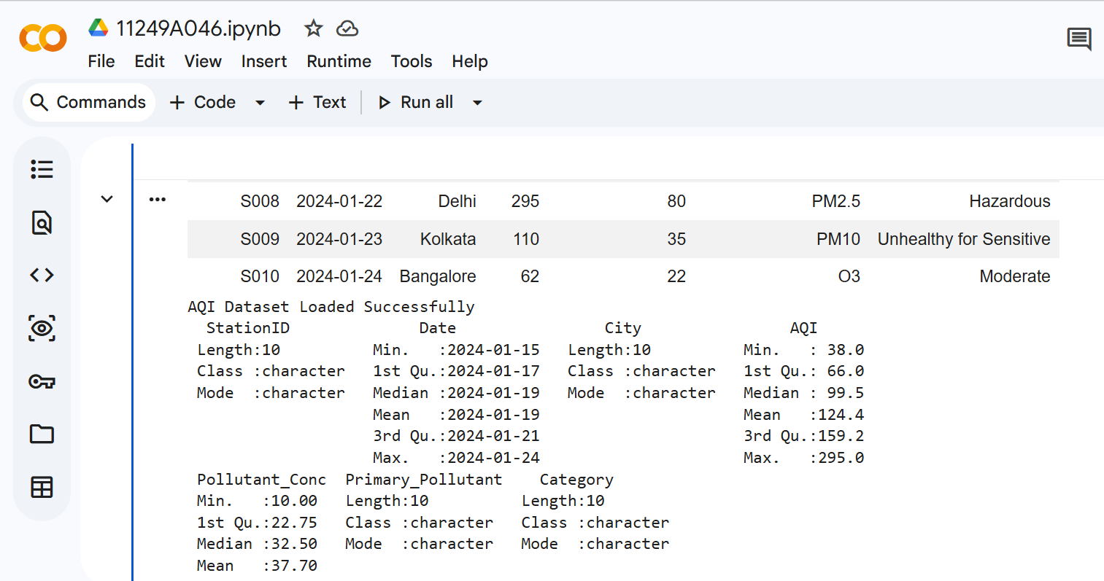

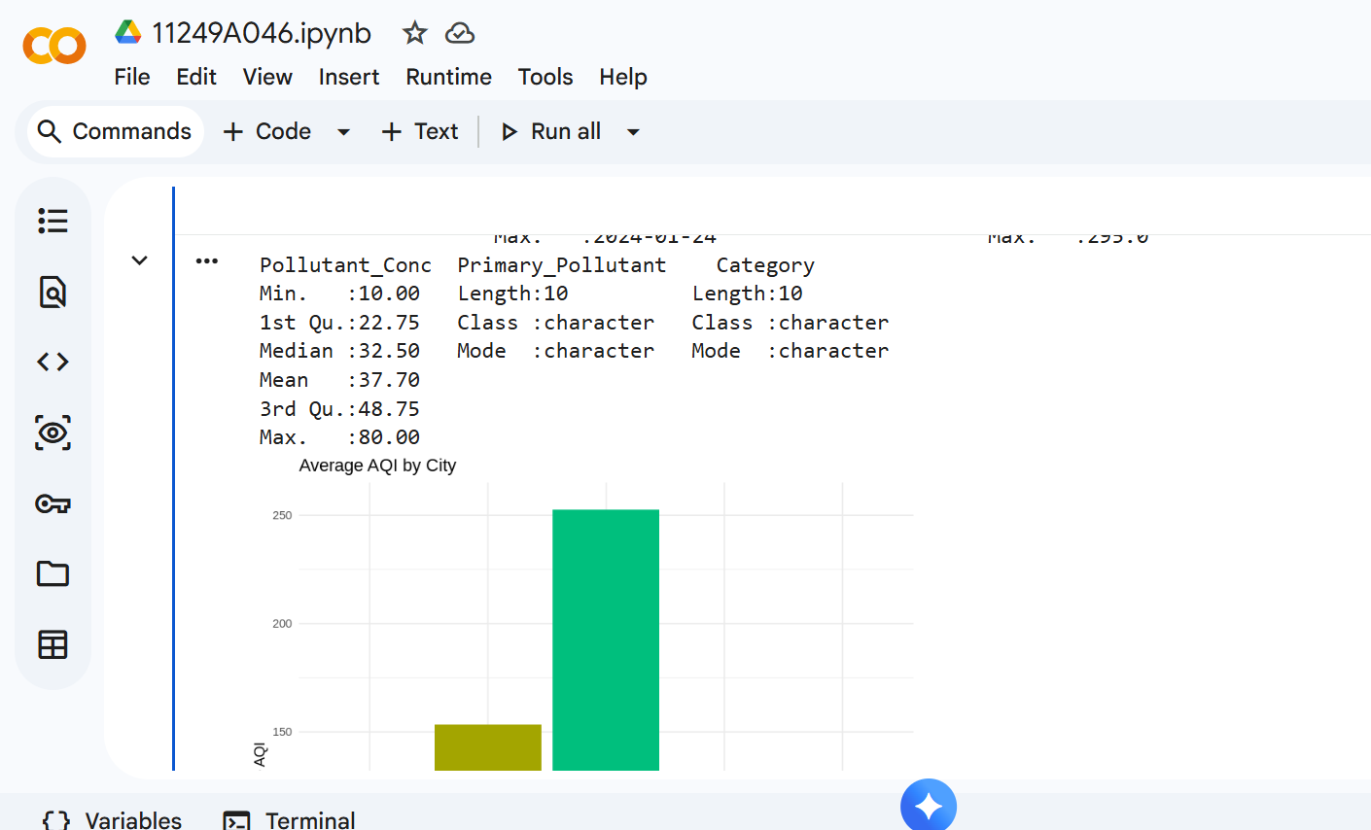

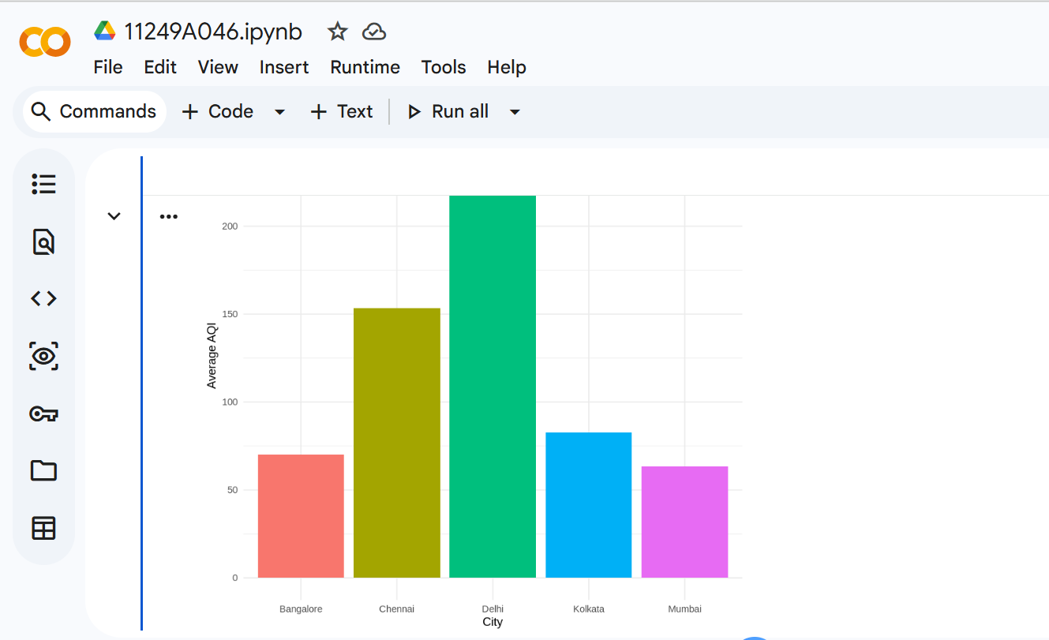

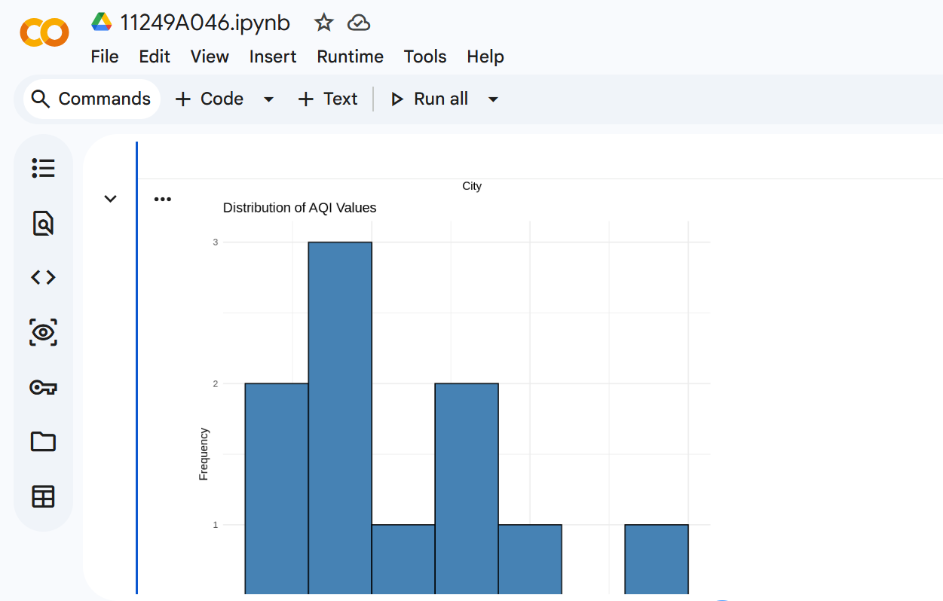

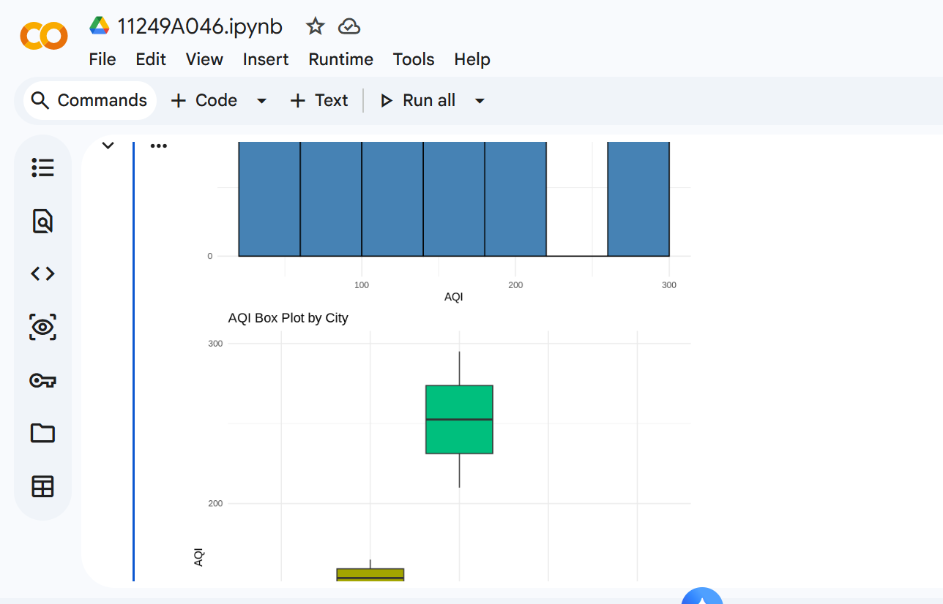

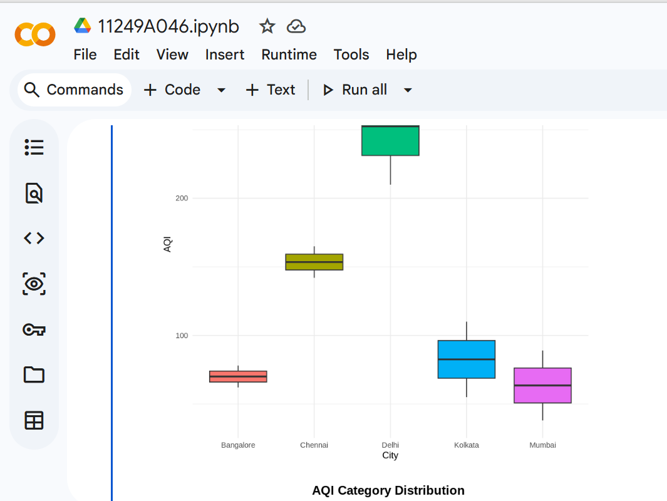

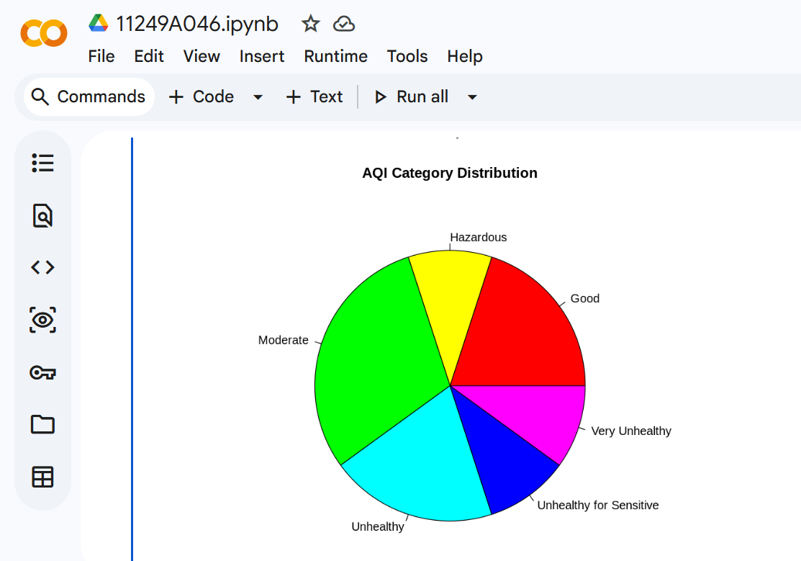

Submitted By
Name : B.Manobhiram
Reg No: 11249A046
CSE, II Year | Section S5
R-Programming Lab
SCSVMV UNIVERSITY

